

i4 Marine Technologies Pvt. Ltd.

**AQUANAUT 30 V3**

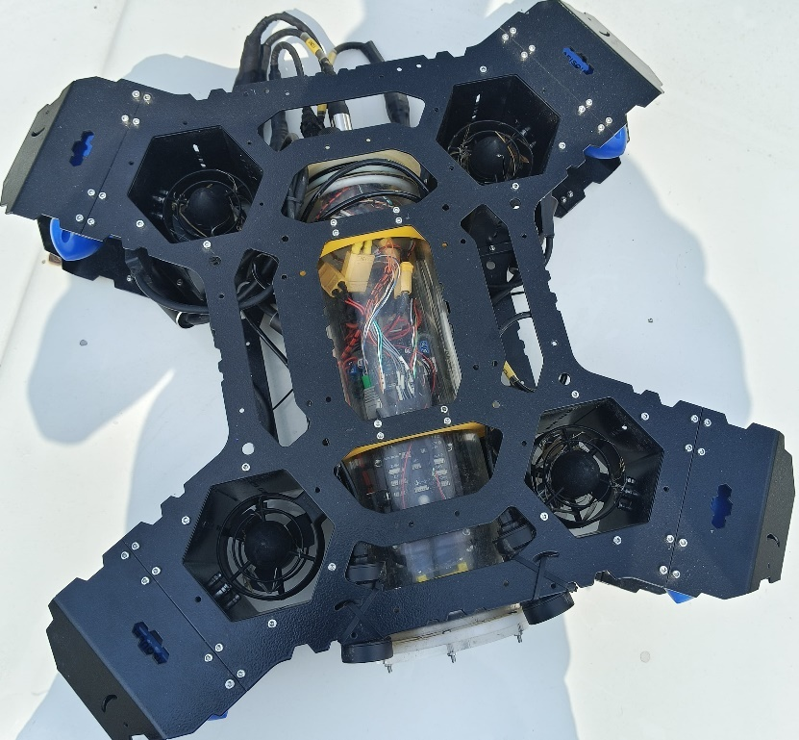

**DOCUMENT No. i4MT/AQUANAUT 30 V3/UM**

**Prepared and published by**

**i4 Marine Technologies Pvt. Ltd. Electronic Estate, Pune Satara Road**

**Pune-411 009**

**[ MAY 2025 ]**

|  |  |  |  |  |  |
| --- | --- | --- | --- | --- | --- |
| **i4 MARINE TECHNOLOGIES**  **PUNE 411 009** | | | | | |
|  | | | | | |
| Title | **User Manual**  **AQUANAUT 30 V3**  Document No. I4MT/AQUA-NAUT 30 V3/UM | | | | |
| Date of issue | **MAY 2025** | Project no | **R.003** | |  |
| Project Team | | Alok Mukherjee  Raja Mahbubani  Prakash Khanzode  Sunny Sebastian  Sunil Paul  Sanjeev Afzulpurkar | | Charles Shaju  Fercinent Thomas  Sony Jojy | |
| Approved By | | (Alok Mukherjee)  **CEO i4 Marine Technologies** | | | |

**User Handbook for aquanaut 30 V3**

CONTENTS

1. **TITLE PAGES**
2. **CHAPTER 1 4**

Introduction

1. **CHAPTER 2 6**

2.1 Applications

2.2 Leading Particular and General Data

1. **CHAPTER 3 8**

Underwater setup and operation guide

1. **CHAPTER 4 14**

System Specification

1. **CHAPTER 5**

5.1 Operating Instruction For Use And installation **15**

5.2 Joystick Controls **18**

5.3 Button Functions **20**

5.4 Modes **23**

1. **CHAPTER 7 29**

AQUANAUT Charging details

1. **APPENDIX –** Mechanical drawings **32**

**CHAPTER 1**

**Introduction**

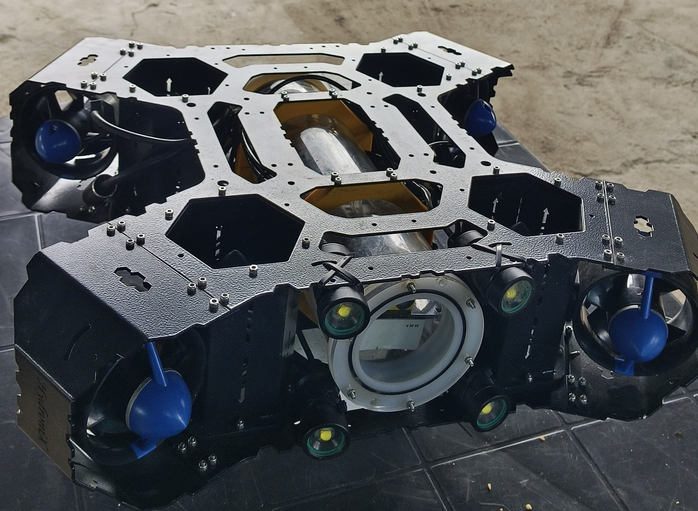

The Underwater Remotely Operated Vehicle (AQUANAUT 30 V3) has been designed and developed as a platform for underwater inspection. The system is tethered vide an electrical cable of 100m length allowing for easily deploy-ability over an area. The AQUANAUT 30 V3 consists of an aluminum chassis as the outer frame of the platform thereby making it rugged, reliable, and giving it long life.

The AQUANAUT 30 V3 is self-contained with its power source, control electronics, communication and navigation hardware placed in its central tube. The AQUANAUT 30 V3 has eight thrusters on-board designed in such a plane and geometry, thereby allowing easy maneuverability to the underwater craft, 6 degrees of freedom. The platform can therefore be easily deployed for underwater inspection.

The thrusters are placed within the frame, hence protecting them from mechanical damage during operations or mission. The rechargeable batteries provide good endurance up to 2hrs.

The AQUANAUT 30 V3 has four powerful lights provided in front and allows the on-board high resolution camera to effective view and record the underwater video as it traverses over the structures.

The AQUANAUT 30 V3 is controlled from the surface using a 100m tether cable wound on a light weight cable drum. The underwater craft is controlled from the surface using a Ground Control Station (GCS) which is based on a Laptop with the Human Machine Interface Software allowing the operator to easily control the craft as well as view the on-board system performance and view the streaming video during inspection. The rov also has recording option to record the live video.

**CHAPTER-2**

**2.1 Applications of AQUANAUT 30 V3**

The AQUANAUT 30 V3 is an advanced underwater rover specifically designed for a range of demanding applications such as dam wall inspections, ship hull monitoring, and underwater research. This highly capable system eliminates the need for human intervention in hazardous underwater environments, making it an essential tool for inspection and exploration tasks.

**Dam Wall Inspections:** Enables thorough examination of submerged structures to identify cracks, erosion, and other potential issues.

**Ship Hull Monitoring:** Provides close-up inspections of ship hulls for maintenance and safety checks without requiring divers.

**Underwater Research:** Facilitates the study of aquatic ecosystems, underwater habitats, and geological formations, supporting scientific discovery.

**2.2 Leading Particulars and General Data**

The Aqua Naut 30 V3 is a robust underwater rover designed for inspections at depths of up to 30 meters. This versatile vehicle is equipped with 8 thrusters that provide 6 degrees of freedom, allowing precise movement in all directions. It can operate continuously for up to 1.5 hours, delivering streaming real-time video to the Ground Control Station on the surface.

The rover is constructed using a durable combination of aluminum and acrylic tube weighing around 9 kg. This weight enhances stability in water, even in challenging conditions. AQUANAUT 30 V3 can achieve a speed of 1.5 knots in still waters, making it effective for a range of underwater tasks.

For visibility, the rover is outfitted with four powerful 4 lights, each providing 1500 lumens of illumination. To monitor depth, a pressure sensor is integrated into the frame, providing accurate real-time data as the rover dives down. Communication is handled through a tether cable, which connects to a cable drum. From the cable drum, a cable leads to the GCS computer. The system is easily controlled using an Operator Console, offering intuitive operation.

The cable drum also features a toggle switch for powering the rover on and off, ensuring quick and easy deployment. With its practical design and advanced capabilities, the Aqua Naut 30 is an excellent solution for a wide range of underwater inspection applications.

**CHAPTER-3**

**Underwater ROV Setup and Operation Guide**

**Hardware Components**

* Pixhawk flight controller
* Raspberry Pi (with BlueOS installed)
* ESCs and thrusters
* Camera (e.g., USB camera)
* Lights (LEDs or waterproof lamps)
* Power source
* Cable drum
* Computer with QGroundControl
* Pressure sensor
* battery

**1. Software Setup**

**1.1 Install BlueOS on Raspberry Pi**

1. Flash BlueOS to a microSD card using raspberry pi imager. (BlueOS will be available on bluerobotics official site)

Install bule0S to your laptop

Then install raspberry pi imager (for flashing OS)

now you want to take an empty SD card insert to a SD card reader and connect to your laptop

open raspberry pi imager under raspberry pi device chooses raspberry pi 4, under operating system select the blueOS (click choose OS -> use custom -> goes to device and select from the location where you installed)

then choose your storage (the SD card in which you want to flash)

click next to flash the OS

1. 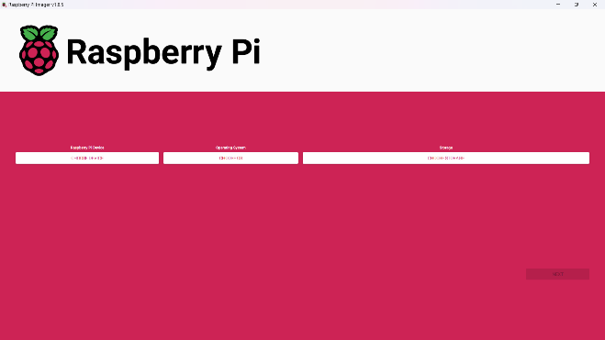
2. Insert the SD card into the Raspberry Pi.
3. Power up and connect to BlueOS via browser (http://192.168.2.2:8080 or appropriate IP).

**1.2 Install and Configure ArduSub**

* Connect Pixhawk to pc using a USB cable and open Qground control, there will a Q icon on the left top corner click on that icon and click vehicle setup there you can see a firmware tab open to install the firmware
* 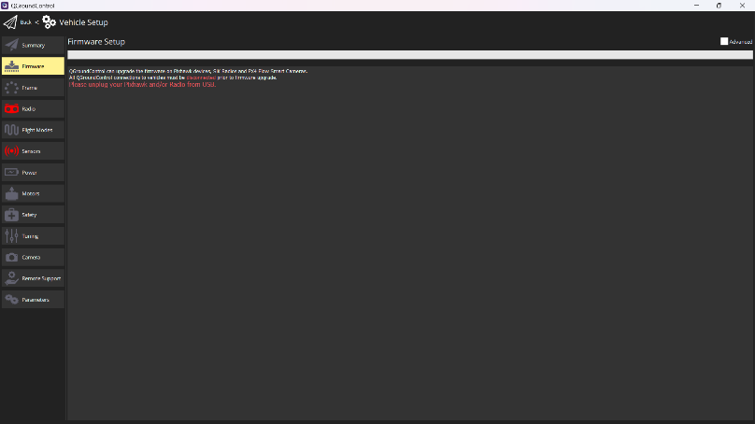

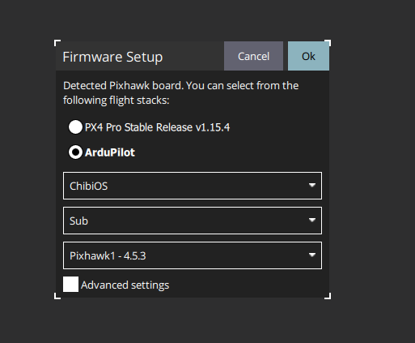

**2. QGroundControl (QGC) Setup**

**2.1 Connect to QGround Control**

* Open QGC on your PC. Go to vehicle setup now you want to calibrate sensors

**3. Compass & Accelerometer Calibration**

1. In QGC, go to **Vehicle Setup** > **Sensors**.

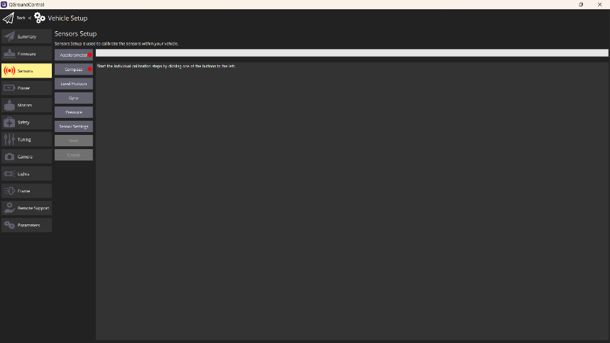

1. Click **acceletrometer**.
2. Follow the instructions (rotate the vehicle in all axes).

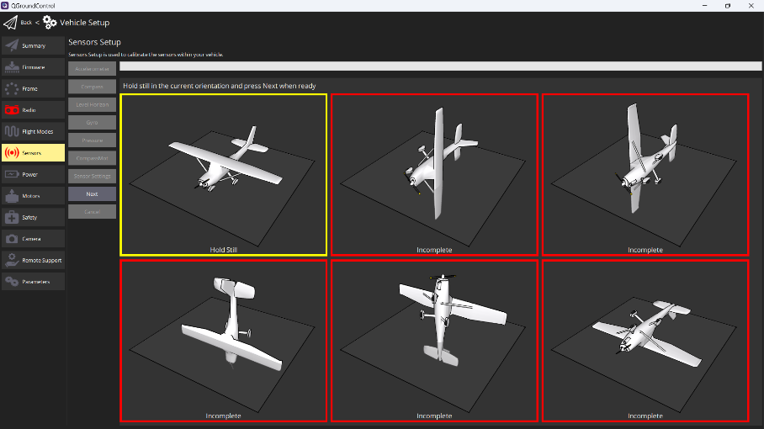

Save and reboot

1. After accelerometer calibration do compass calibration calibration

5. Start the individual calibration steps by clicking one of the buttons to the left.

Rotate the vehicle randomly around all axes until the progress bar fills all the way to the right.

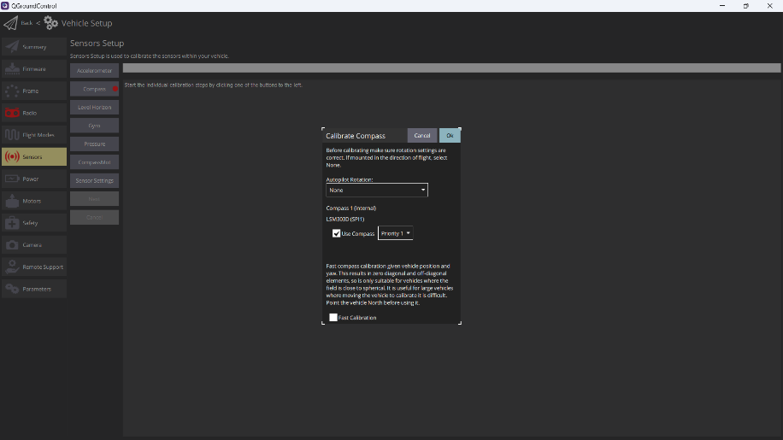

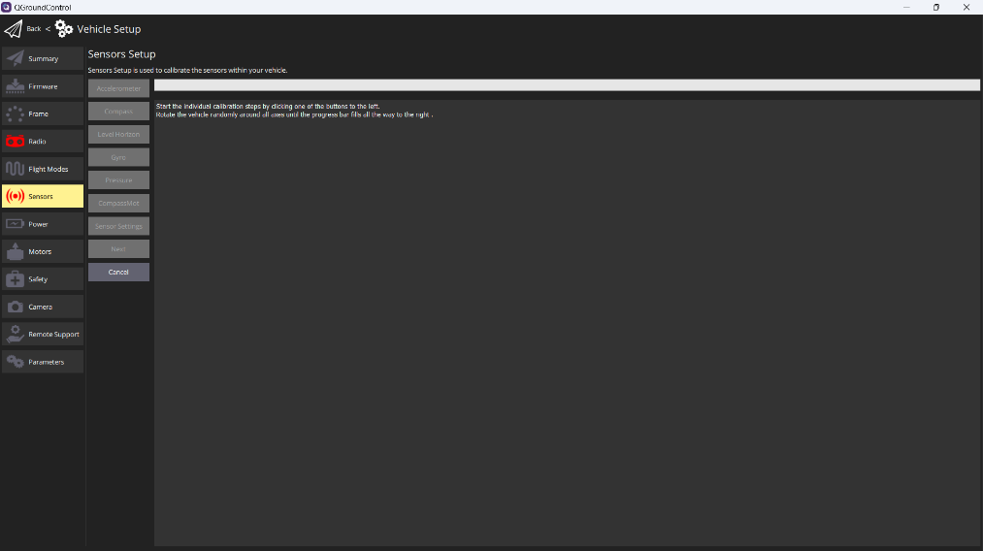

Save and reboot.

**4. Joystick/Gamepad Calibration**

1. Connect your joystick/gamepad to your PC.
2. In QGC, go to **Vehicle Setup** > **Joystick**.
3. Select your joystick and click **Calibrate**.

The Operator Console may require calibration before you can enable it for use in AQUANAUT HMI. If your Operator Console requires calibration, the **Joystick** tab on the **Vehicle Settings** page will be yellow, and you should follow these steps to calibrate your console. If your console does not require calibration, the **Joystick** tab will not be yellow, and you can skip this step!

1. Go to the **Vehicle Settings** page in AQUANAUT HMI, then click on the red **Joystick** tab in the sidebar on the left. If you do not see a **Joystick** tab, this indicates that the Console is not detected by HMI or not connected to the computer.

2. When the Operator Console is connected, in the **Joystick** tab, on **General** settings, Tick the checkbox that says **Enable Joystick.**

1. Click **Calibration settings**, then click **Start**.

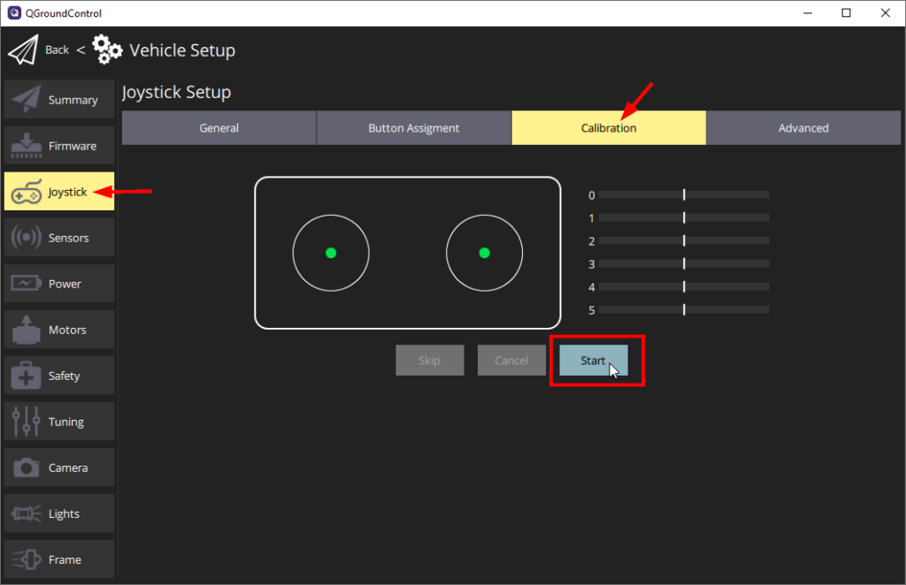

1. 4. Follow the step-by-step instructions and move the sticks as indicated in AQUANAUT HMI.
2. When completed, the **Joystick** tab will no longer be red, and the **Enabled** checkbox on the Joystick page will be enabled.
3. Follow the prompts to calibrate axes and buttons.
4. Assign joystick buttons for functions (e.g., arming, mode change, lights).

**Button Setup**

The default button setup for the AQUANAUT 30 V3 is shown below:

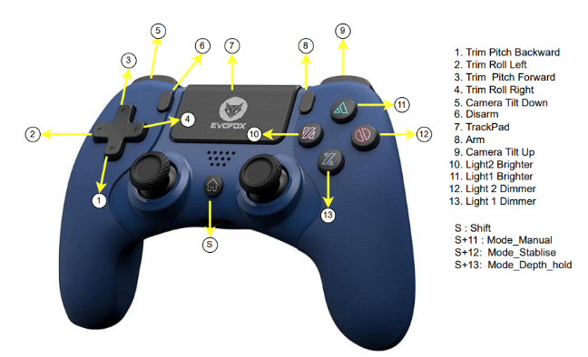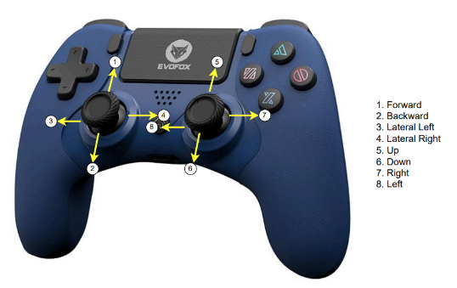 Default setup

The button layout can be configured

The button layout can be configured in the **Joystick** tab on the **Vehicle Setup** page under **Button Assignment**.

1. Go to the **Vehicle Setup menu** then select **Joystick** from the sidebar.

2. Under **Button Assignment**, AQUANAUT HMI shows a list of all the buttons and their assigned functions.

3. Press the button that you want to change on the controller. The corresponding button number in the list will light up next to the functions that are assigned to it. The functions are listed in two columns labelled **Function** and **Shift Function**.

* The function listed in the first **Function** column is triggered when the button is pressed normally.
* The function listed in the second **Shift Function** column is triggered when the button is pressed while the **Shift** button is held down.
* The default shift button is the HOME button on the EvoFox controller.

4. Select the desired function and shift function for the button from the dropdowns to the right of the button number. Be aware that not all button functions that are displayed are supported. A list of the most common button functions is provided below.

Below is a list of the common button functions and the associated button function parameter as it is displayed in the AQUANAUT HMI dropdown.

| **Function** | **Button Function Parameter** |
| --- | --- |
| Arm | arm |
| Disarm | disarm |
| Shift | shift |
| Camera Tilt Up | mount_tilt_up |
| Camera Tilt Down | mount_tilt_down |
| Lights Brighter | lights1_brighter |
| Lights Dimmer | lights1_dimmer |
| Trim Pitch Forward | trim_pitch_inc |
| Trim Pitch Backward | trim_pitch_dec |
| Trim Roll Right | trim_roll_inc |
| Trim Roll Left | trim_roll_dec |
| Manual Mode | mode_manual |
| Depth Hold Mode | mode_depth_hold |
| Stabilize Mode | mode_stabilize |
| Camera Tilt | mount_tilt_up |
| Open Gripper | servo_#_max_momentary* |
| Close Gripper | servo_#_min_momentary* |
| *\*Where # is the servo number corresponding to the output channel the Gripper is connected to. Refer to the servo function mapping table below.* | |

| **Servo Function Number** | **Navigator Output Channel** | **Pixhawk 1 Output Channel** |
| --- | --- | --- |
| servo_1 | 9 | Aux 1 |
| servo_2 | 10 | Aux 2 |
| servo_3 | 11 | Aux 3 |

**5. Assigning Channels for Lights**

1. In QGC, go to **Vehicle Setup** > **light tab**
2. Connect the light pwm pin signal to Pixhawk aux pins say 1 on the qgc light tab chose channel 9
3. Assign a joystick button to control lights under **Joystick Button Actions**.

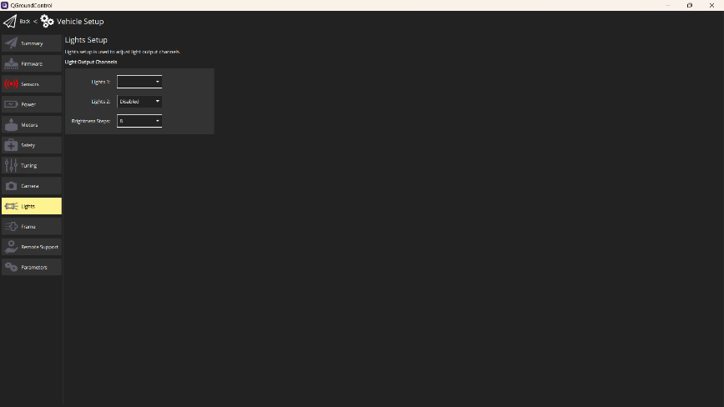

**6. Frame setup**

* In QGC > **Vehicle Setup** > **frame**

Select 8 thruster configuration frame for Aquanaut 30 v3

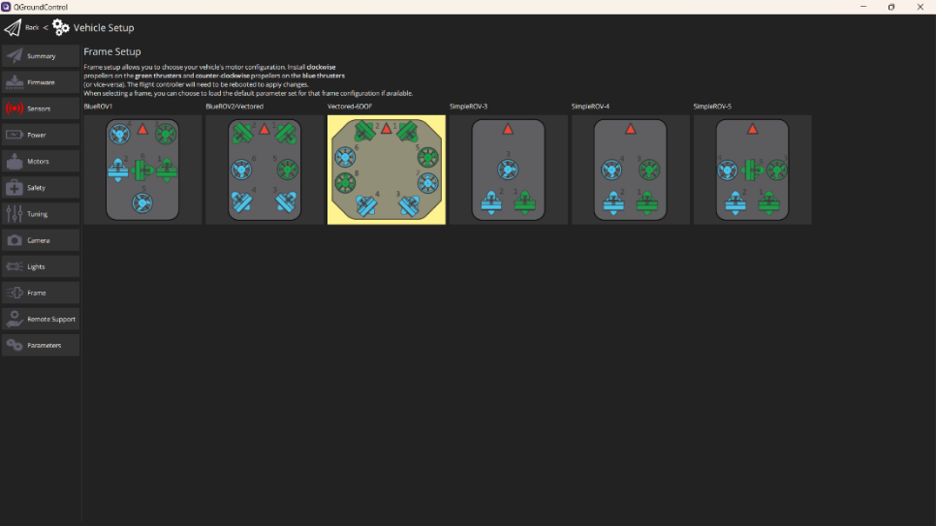

**7. Power setup**

1. In QGC, go to **Vehicle Setup** > **power**

**1. Wiring Check**

Ensure the **Power Module** (e.g., 3DR-style or Mauch, etc.) is properly connected to your **Pixhawk**:

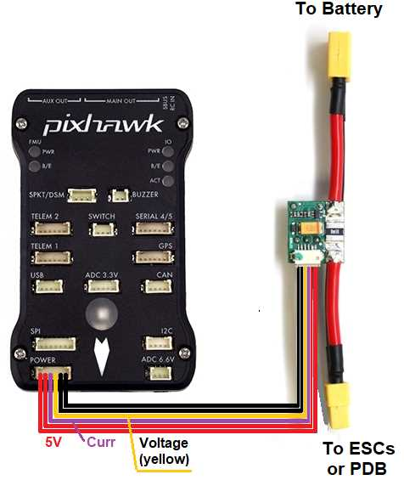

* Power Module → **Power port** of the flight controller.
* The module measures **voltage and current** and sends it via the **analog signal** (depending on module).

**2. Open QGroundControl → Power Setup**

1. Connect your pixhawk to QGroundControl (via USB)
2. Go to the **"Power" tab**:  
   QGroundControl → Vehicle Setup → Power

**3. Battery Configuration**

1. Set **Battery Number 1**:
   * **Battery chemistry**: LiPo
   * **Number of cells**: 4
   * **Full voltage per cell**: 4.2 V
   * **Empty voltage per cell**: 3.5 V (or 3.3 V for aggressive cutoff)
2. **Total full voltage** = 4.2 V × 4 = **16.8 V**  
   **Total empty voltage** = 3.5 V × 4 = **14.0 V**

**4. Power Sensor Configuration**

1. Under **Power Setup**
   * select Analog Voltage and Current
2. If using a **custom power module**, you may need to manually enter:
   * **Voltage divider**
   * **Amps per volt**

Example values (for standard 3DR Power Module):

* Voltage Divider: **10.1**
* Amps per Volt: **17.0**

**5. Calibrate Voltage and Current (optional but recommended)**

* Use a **multimeter** to measure actual battery voltage and current draw.
* Adjust the **voltage divider** and **amps per volt** until QGC shows accurate readings.

1. In QGC Vehicle Setup, click on the **Power** tab in the left sidebar.

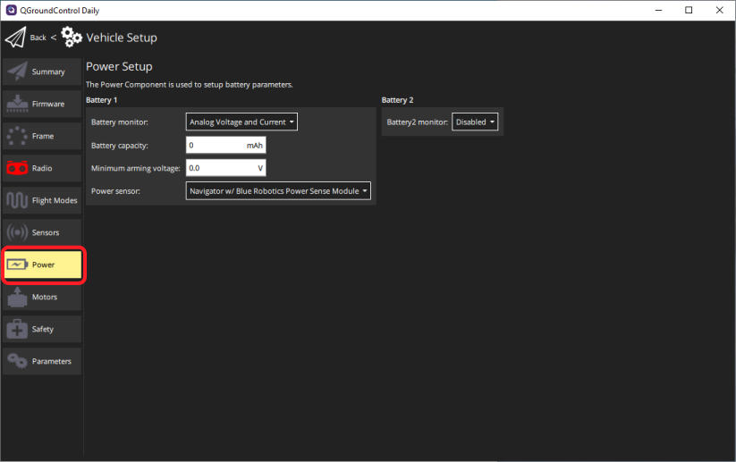

2. Select “Analog Voltage and Current” from the **Battery monitor** dropdown.

3. Select the correct option from the **Power sensor** dropdown menu.

* If using a Blue Robotics Power Sense Module, select “Navigator w/ Blue Robotics Power Sense Module” from the dropdown menu. No further configuration is necessary.

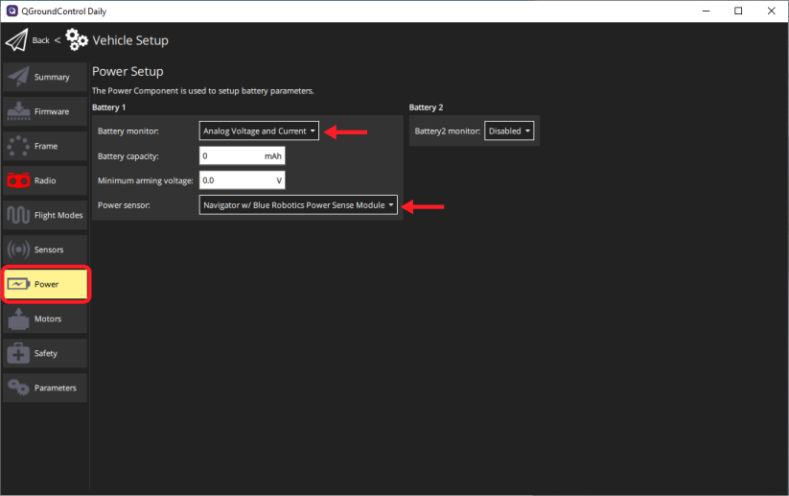

* If using any other type of power module, select “Other” from the dropdown menu and proceed to the next step.

4. Set the **Current pin** dropdown menu option to “CubeOrange_PM2/Navigator” and set the **Voltage pin** dropdown menu option to “Navigator”.

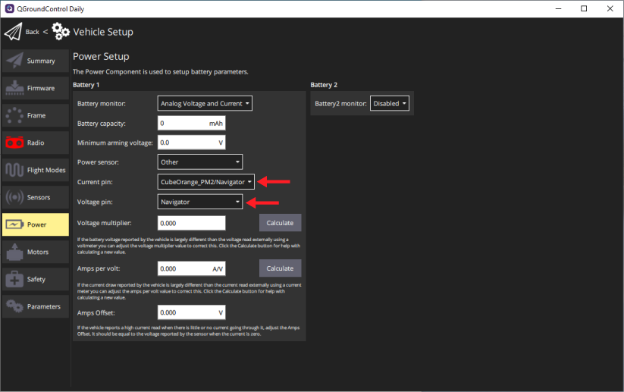

5. Enter the **Voltage multiplier**, **Amps per volt**, and **Amps Offset** values according to your power module’s documentation.

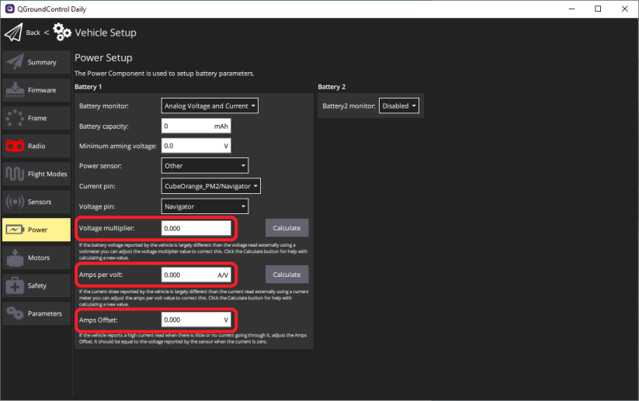

**6. Save and Reboot**

After setting the values:

* Click **"Calibrate"** or **"Save"**
* Reboot your flight controller to ensure settings are retained.

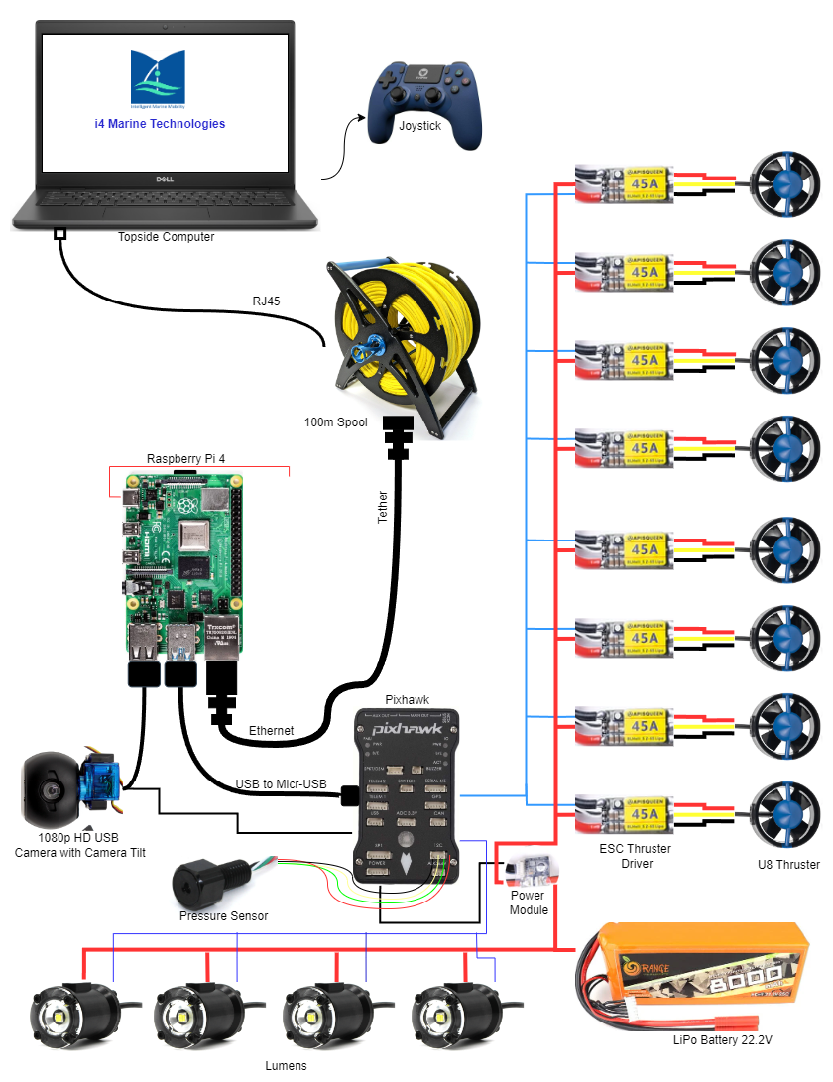

**Internal Connection Setup**

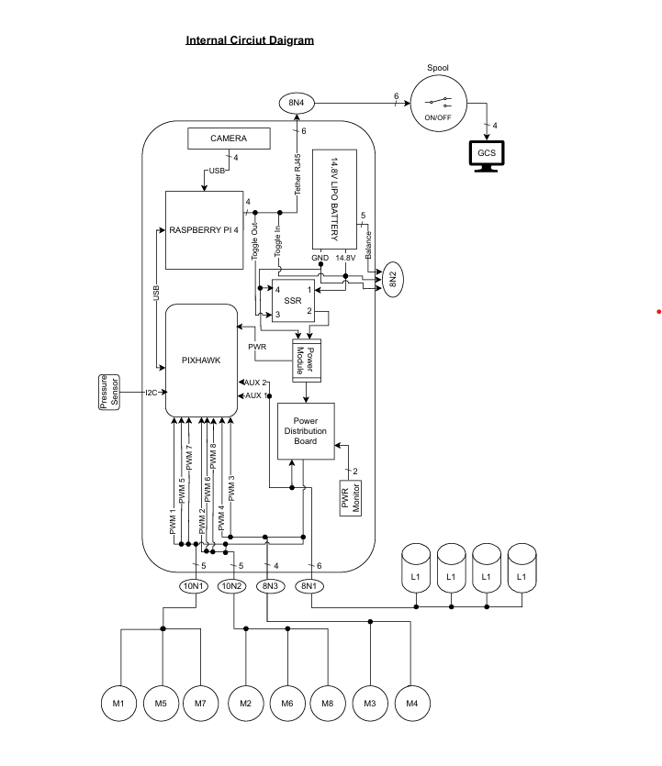

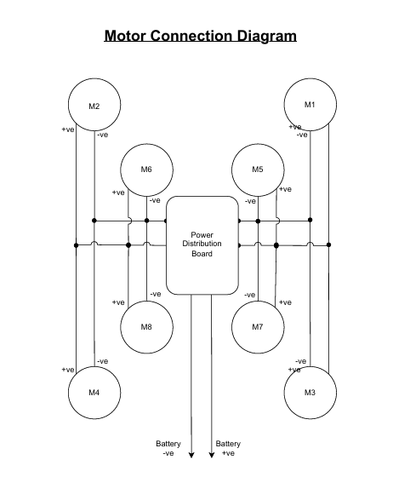

**CHAPTER 4**

**SYSTEM SPECIFICATION**

AQUANAUT 30 V3 is a Remotely Operated Vehicle (ROV) which can be deployed for underwater survey of structures like dams, bridge piers and buried artefacts. The specifications of AQUANAUT 30 V3 are as follows:

**Size** : 440m X 500m X 140mm

**Weight**  : < 9 kg

**Construction** : Aluminum material and Modular allowing for easy maintainability

**Depth Rating** : 30m

**Speed**  : 2 knots

**Endurance**  : 2 hours using Lithium battery

**Stance**  : Holding capability in different configurations at different depths

**Power**  : 4 thrusters with 1.3kg thrust and 4 thrusters with 7kg thrust

**Vision**  : 1080p HD Underwater Camera with remotely controlled tilt axis

**Control** : Through electrical tether cable

**Payload** : Configurable as per Users’ requirement (customization can be carried out)

**Internal compartment** : Water sealed space for user defined payloads

**Ground Control Station** : Intel i3 based Laptop with Ubuntu OS,

**Interface Cable** : 100m tether Cable on Cable Drum.

**Human Machine Interface** : Specially designed User interface

**CHAPTER 5**

* 1. **OPERATING INSTRUCATION FOR USE AND INSTALLATION**

**Step1 Connect the System:**

* + At the back side of the rov you can see the female connector panel. one of the 8 pin female connectors (under the connector its written tether) is used to connect the tether cable (which is used for communication) from the cable drum you can a connect a green cable with a black male connector to the tether connector.

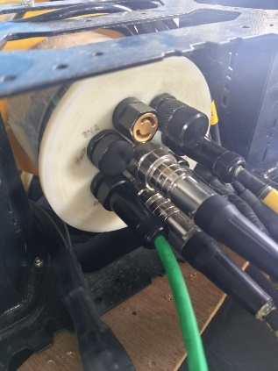

* + You can see an ash ethernet cable from the cable drum. Connect it to the ethernet port of your laptop.

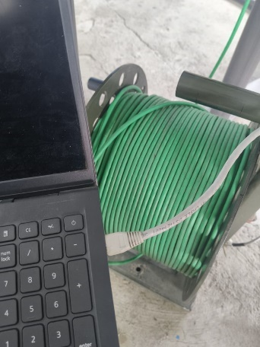

**Step2 Power On the ROV:**

* + On the **cable drum**, flip the **toggle switch** to turn on the system.

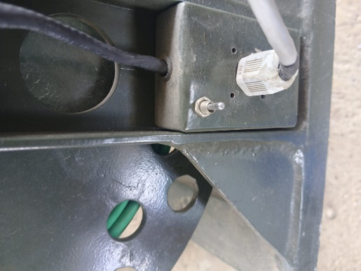

* + The **ROV powers up automatically**.

**Step 5: Open AQUANAUT 30 V3 HMI Software.**

- On your laptop, launch the Aquanaut 30 V3 HMI software.

- The software will be preconfigured to interface with the Aquanaut 30 V3 ROV.

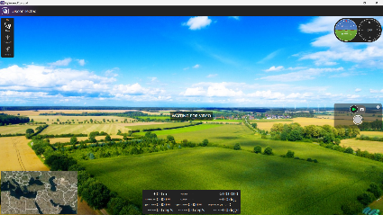

**AQUANAUT 30 V3 HMI**

{Note: If you are using a new laptop, you should configure the IP address of the adapter that is connected.

**NETWORK SETUP OF AQUANAUT 30 V3**

{Note: Configuration to be carried out when connected with new laptop)

1. Go to the Windows **Control Panel** then select **Network and Sharing Center**.

2. under view your active networks. There will a network shown as unidentified network. Next to that you can see an option like access type and connections, click ethernet and enter to properties

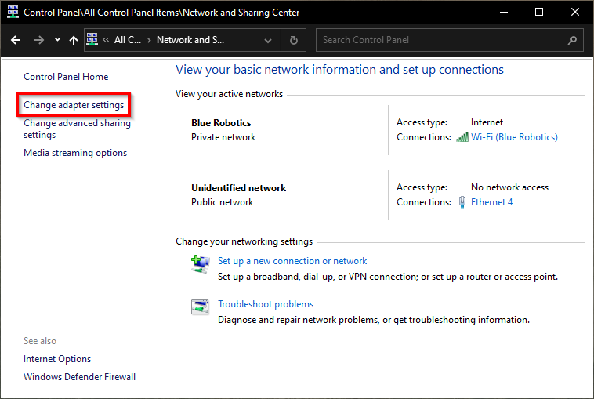

4. In the properties dialog, click on **Internet Protocol Version 4 (TCP/IPv4)** to highlight it, then Click **Properties**.

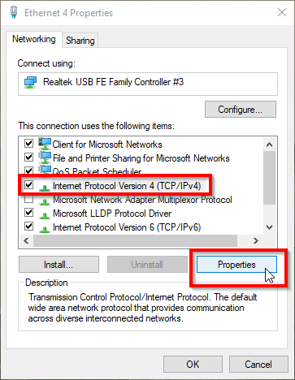

5. Select “Use the following IP address” And enter **192.168.2.1** for the IP address and **255.255.255.0** for the Subnet mask. Select **OK**, you can then close out the rest of the windows.

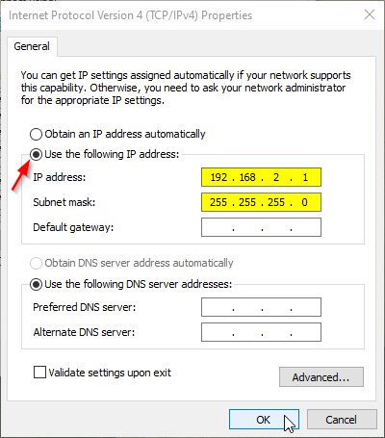

**Now the HMI should show that it is connected and live camera feed should be visible.**

**Step 6: Wait for Software to Load**

- The connection process may take up to 2 minutes. Once the connection is established, the

AQUANAUT HMI interface will change from Disconnected to Ready to Fly.

- You should also see the live camera feed from the ROV within the software.

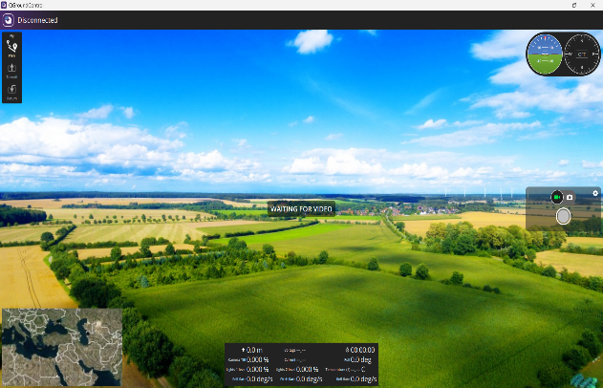 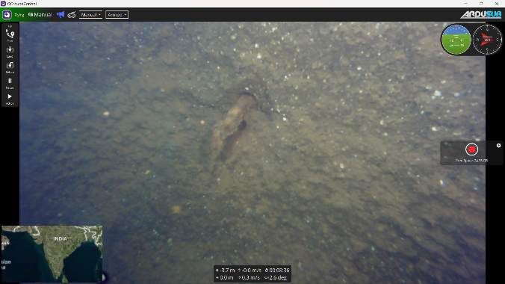

**Before Connection After connection**

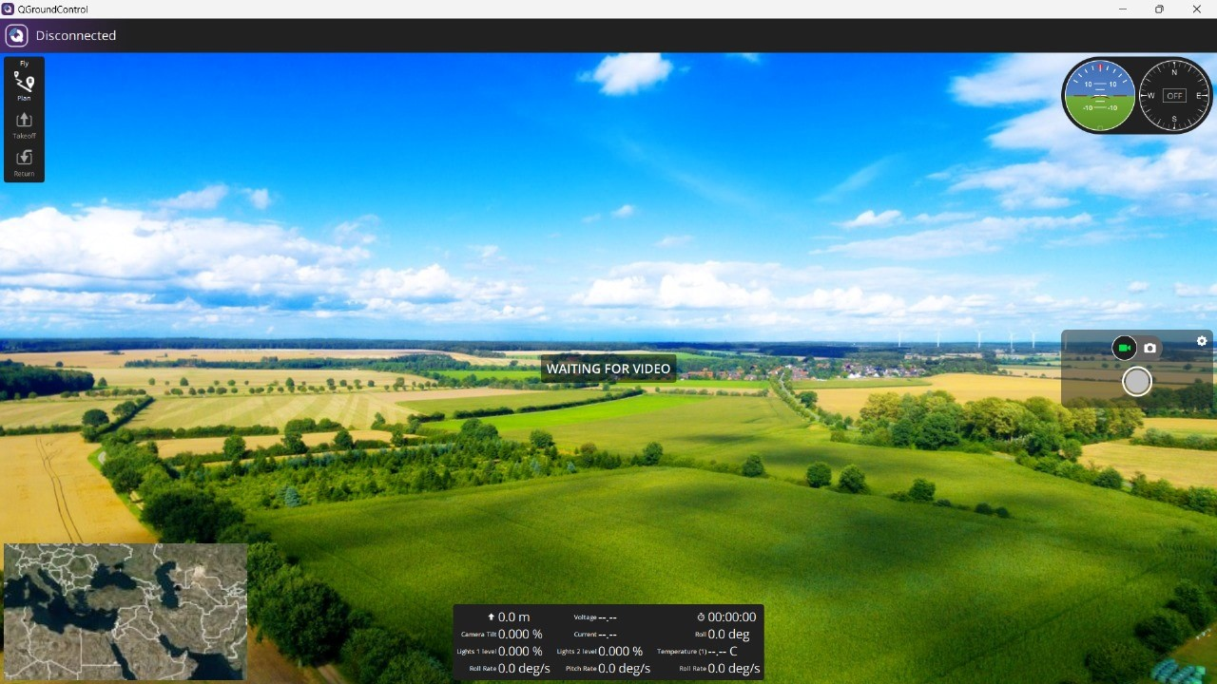

Gyro and Compass

Video Record

Data Panel

Map

Platform e Setup

Light 1 Intensity

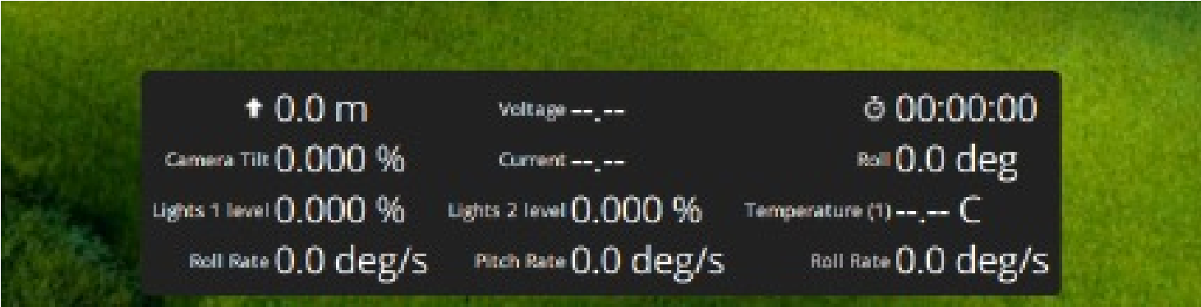

Vehicle Depth

Battery Voltage

Runtime

Camera tilt Percentage

Light 2 Intensity

Internal Temperature

**Step 8: Connect and Configure the Joystick.**

- Plug the joystick controller into your laptop.

- On AQUANAUT V3 30 HMI software, the joystick status indicator (top left of the interface) should turn from red to white, showing it is connected.

{Note: If it is your first time using the joystick or if you change the joystick, So, you will see a yellow joystick indication while connected which indicates that calibration of the remote is required. You can refer chapter for calibration of your new Joystick}

**Step 9: Test Joystick Controls**

- Before deployment, test the controls to ensure the ROV responds correctly to joystick inputs.

(Power on the rov. after connection is established, you can just move the throttle stick to check the rov is responding to the joystick) (e.g if you want to check the lights press the button assigned to the light to joystick and check whether the lights are working)

**Step 10: Deploy the ROV**

- Once all connections and controls are verified, you can deploy the ROV into the water for your mission.

- Press the Arm button on the game controller for turning on the motor controls.

**IMPORTANT PRECUATIONS**

- Tight the Charger Connector cap and Tether Connector before deployment (it will be in back side connector Pannel of the rov)

- Before deploying the AQUANAUT 30 V3, ensure that the HMI connection is established.

- After deploying the AQUANAUT 30 V3, confirm that the vehicle is neutrally buoyant. (This is checked by deploying the rov in water. If half the rov is under water and other half is on top it means its neutrally buoyant. If the rov is sinking without operating it means the rov is negatively buoyant in this case you want to take the rov back and check whether there is any leak)

- If the controls are not working as expected ( for checking after arming the rov just move the joystick stick front and back), redo the calibration.

- Follow safety guidelines and operational limits for depth and environmental conditions.

**5.2 JOYSTICK CONTROLS**

**Connecting the Controller:**

The EVOFOX is our recommended controller for the best experience. The Logitech F310 is also a good alternative for a more affordable option.

The Game controller is plug-and-play with Windows systems. It can be used wired with a USB-C cable or wirelessly via Bluetooth. To use the controller wirelessly, your computer must have Bluetooth enabled and the controller must be paired from the Bluetooth settings menu.

To pair the controller with your computer:

1. Turn on the EVOFOX controller by holding down the middle HOME button for 3 seconds. You can see that the light blink faster now. This means the controller is ready to pair.

2. Open the Start menu and go to **Settings** > **Devices** > **Bluetooth & other devices**.

3. In the Windows Bluetooth menu, select **Add Bluetooth or other device** and select the Bluetooth option.

4. Select the controller from the list. The controller must be in pairing mode to show up as a selectable device.

5.Now the controller will be connected through Bluetooth.

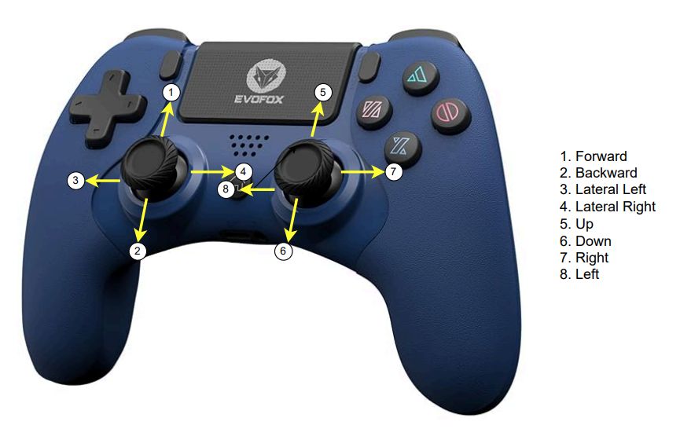

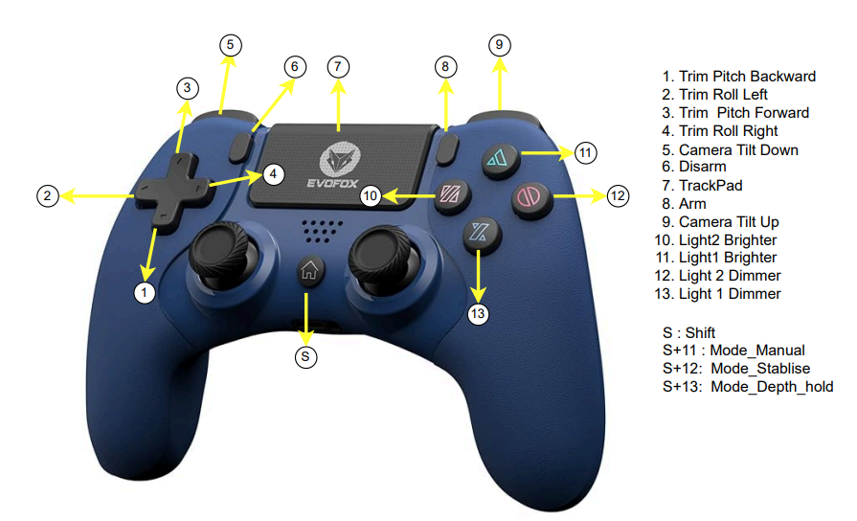The joystick of the game controller controls the basic functions of the AQUANAUT like forward, back, left, right, up and down.

The buttons are assigned with specific functions like turning on the lights, tilting the camera, changing modes of the vehicle. For changing the modes of the vehicle press the shift button with the assigned pins (shift + 12 = To change the mode to Stabilise).

**5.3 Button Functions:**

**1. Trim Pitch Backward:** Adjusts the ROV's pitch trim to point the nose slightly upward.

**2. Trim Roll Left:** Adjusts the ROV's roll trim to tilt the ROV to the left.

**3. Trim Pitch Forward:** Adjusts the ROV's pitch trim to point the nose slightly downward.

**4. Trim Roll Right:** Adjusts the ROV's roll trim to tilt the ROV to the right.

**5. Camera Tilt Down:** Tilts the camera downward.

**6. Disarm:** Disarms the ROV's motors and autopilot system.

**7. Arm:** Arms the ROV's motors and autopilot system.

**8. Camera Tilt Up:** Tilts the camera upward.

**9. Light2 Brighter:** Increases the brightness of light 2.

**10. Light1 Brighter:** Increases the brightness of light 1.

**11. Light 2 Dimmer:** Decreases the brightness of light 2.

**12. Light 1 Dimmer:** Decreases the brightness of light 1.

**5.4 Modes of Operation:**

**1. Manual Mode (S+11):** In this mode, the pilot has direct control over the ROV's movements and actions. The ROV will respond immediately to joystick inputs.

**2. Stabilize Mode (S+12):** In this mode, the ROV maintains its current depth, roll, and pitch. The pilot can still control the ROV's movements, but the autopilot system will try to stabilize the ROV's orientation.

**3. Depth Hold Mode (S+13):** In this mode, the ROV maintains its current depth, but the pilot can still control the roll, pitch, and yaw.

These modes and button functions allow the pilot to control the ROV's movements, adjust its orientation, and manage its lights and camera.

**To The First Dive!**

Your computer setup is now complete! Please continue to our AQUA-NAUT 30 V3 Operation Manual for getting ready for your first dive!

**CHAPTER 7**

**AQUANAUT 30 V3 Charging**

* Charging of the AQUANAUT 30 V3 is carried out by iMAX B6AC with a Charging cable.

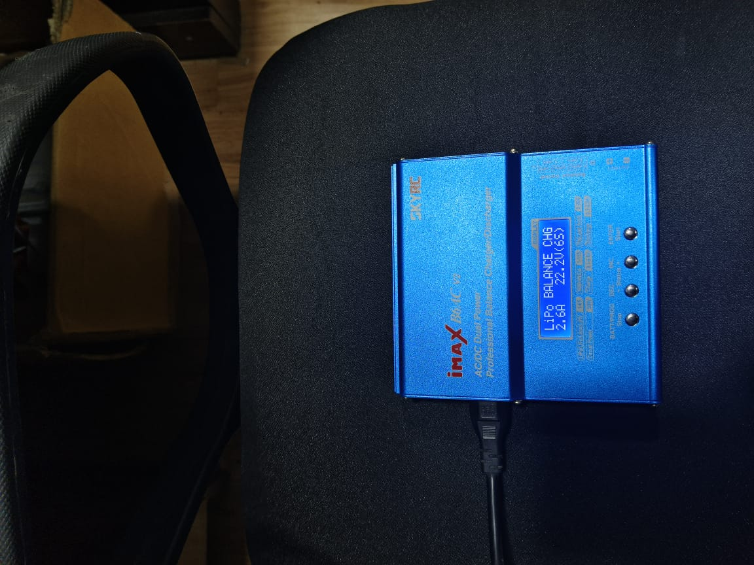 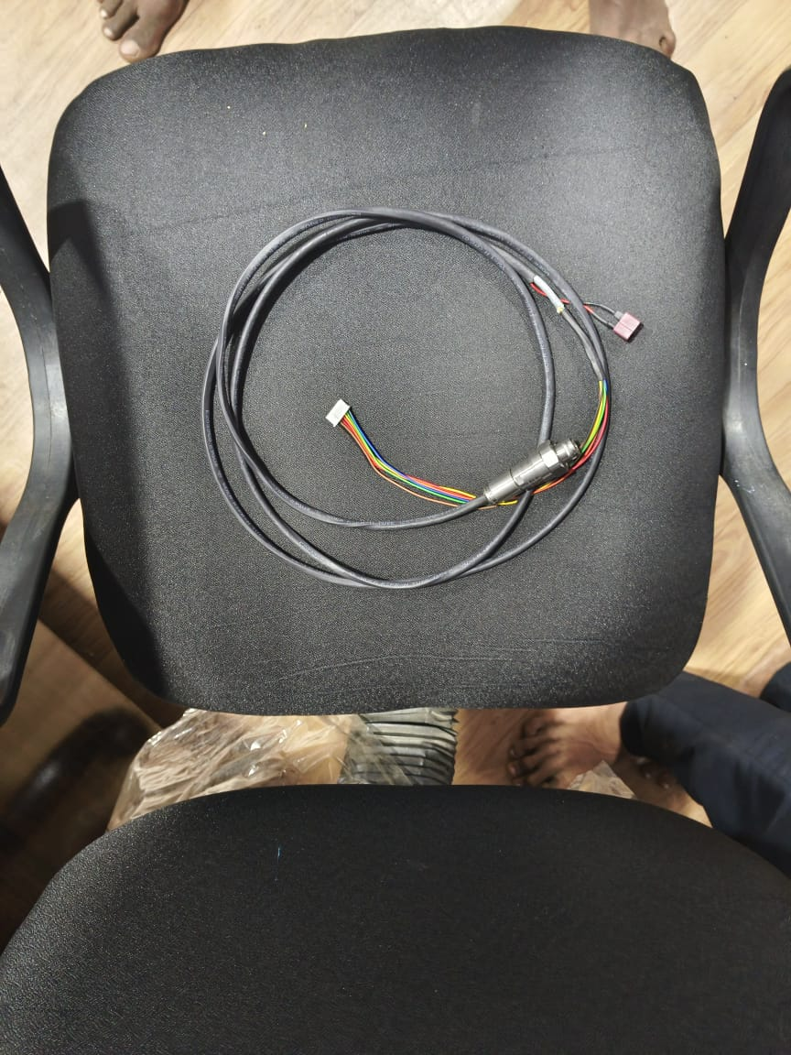

iMAX Charger Charger Cable

* 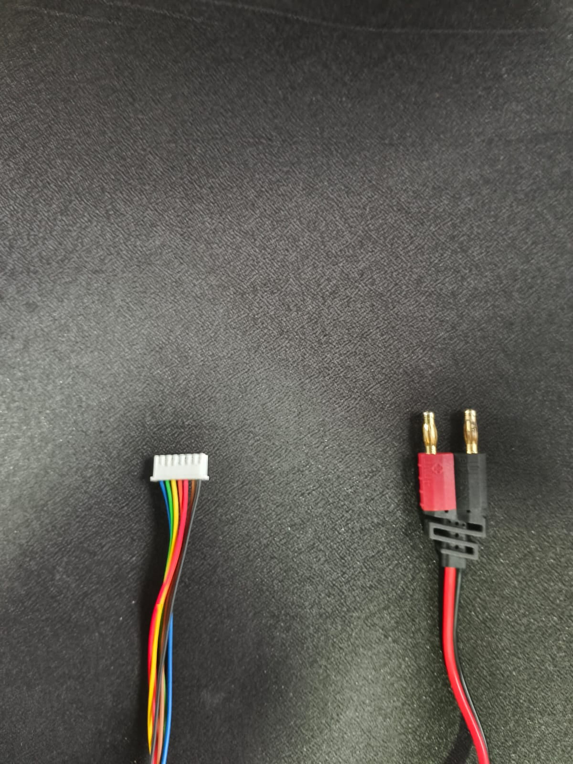The Charger cable comes with a 8 pin Connector on one end and on the other end a JST-EHR-7 pin connector and a Bannana Plug.

JST-EHR-7 pin connector and a Bannana Plug

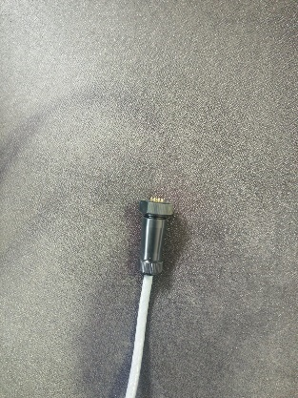 8 pin connector

* Connect the 8 pin Connector to the Charging Connector which is on the back side of the Aquanaut.

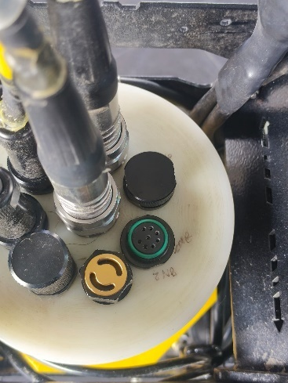 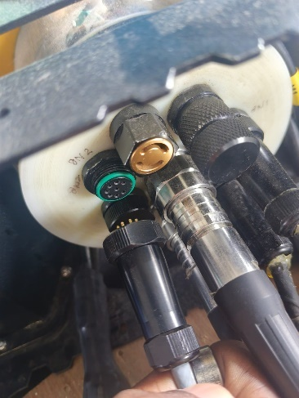

Charging port connection

* On the charger side, plug in the Bannana Plug in to the postive and negative terminals of the iMAX charger. Connect the JST pin to its slot as shown in the picture below for Balance Charging.

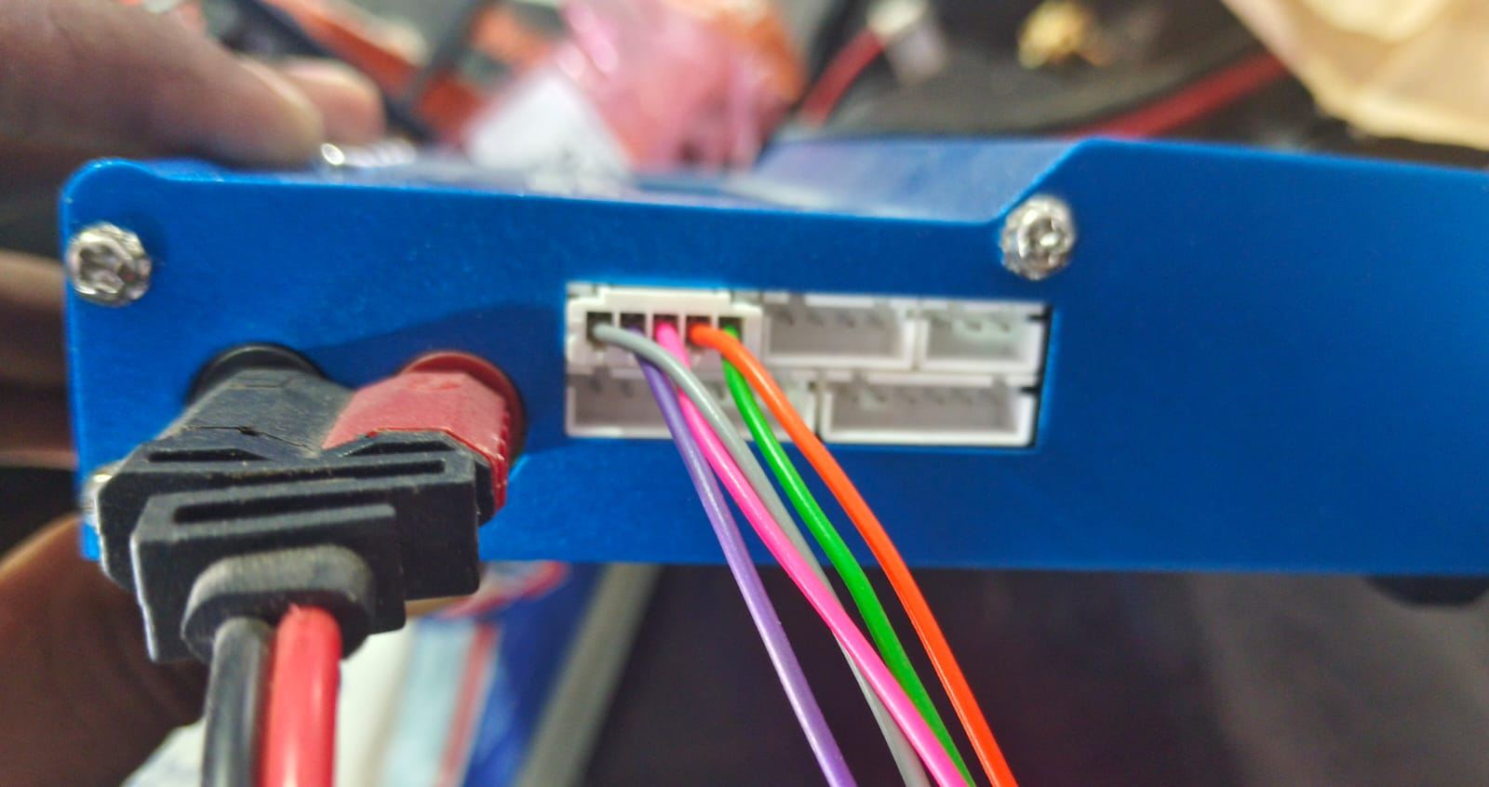

* Turn on the Charger. You can see the display as seen below. You can set the current and voltage in which the battery is to be charger. Normally you can charge with upto 4 Amp in balance charging. And the voltage should be set to 14.8v (4s).

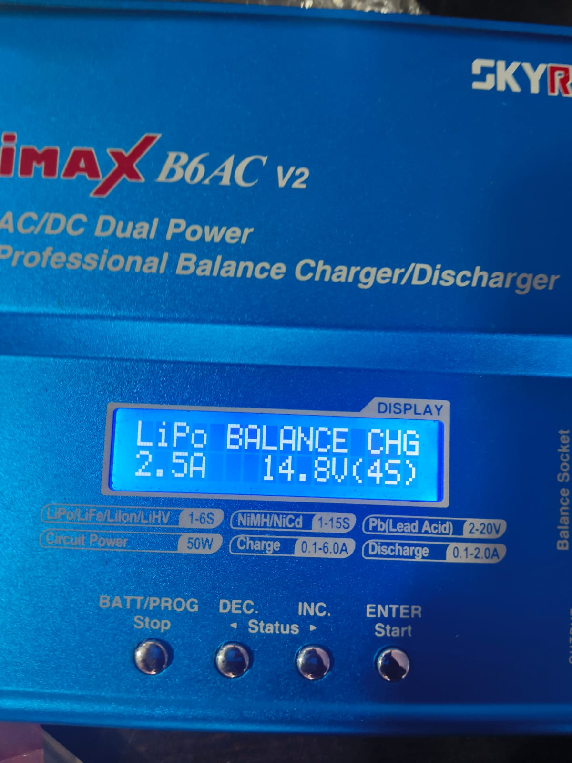

* You can set the battery type and click Enter to select. Use Dec/< and Inc/> to navigate through the selection.Use Lipo Balance Charging mode for better battery life.
* After setting the voltage and Current, click enter. The Charger will check the battery status. If everything is okay, it indicate whether the process should continue or terminate.Long press the Enter Button and the charger will start charging the battery.
* When the charging is finished you will hear a beeping sound from the charger. After hearing the sound click on stop button. Now you can remove the Charging cable.The full charge battery voltage would be approximately 16V.

Precautions:

* After removing the charger cable connect the charger cap tightly.
* It is better to charge the battery once in a month for better battery health.

**APPENDIX- MECHANICAL DRAWING**

